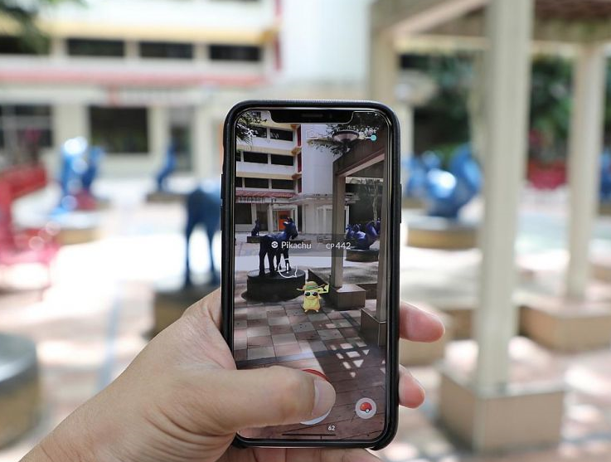

Augmented Reality

Use cases and application

SDP

By: Moxank Patel ~CE001

Aatish Chaudhari ~CE003

Jaimin Chauhan ~CE

Guided By: Prof. Jigar. M. PandyaWhat is Augmented Reality (AR)

* It’s an interactive experience of a real-world environment where the objects that reside in the real world are enhanced by computer-generated perceptual information, sometimes across multiple sensory modalities, including visual, auditory, haptic, somatosensory and olfactory (smell).
* Augmented reality is the result of using technology to superimpose information —sounds, images and text.

## Augmented reality vs. virtual reality

* Virtual reality means computer-generated environments for you to interact with, and be immersed in.
* AR adds to the reality you would ordinarily see rather than replacing it.
* AR is more like visualizing something in real world.
* VR is more like visualizing whole real world.

## Augmented reality in today's world

* AR has been in uses since 90’s, for example, the heads-up displays in many fighter aircraft would show information about the attitude, direction and speed of the plane, and only a few years later they could show which objects in the field of view were targets.
* In the past decade, various labs and companies have built devices that give us augmented reality. In 2009, the MIT Media Lab's Fluid Interfaces Group presented SixthSense, a device that combined the use of a camera, small projector, smartphone and mirror. The device hangs from the user's chest in a lanyard fashion from the neck. Four sensor devices on the user's fingers can be used to manipulate the images projected by SixthSense.
* Recently AUGMEDICS got approved by FDA in USA that allows Doctors to perform spinal surgery. AUGMEDICS has XVS (XVISION Spine System) that uses AR to assists doctors to allow them visualize spinal cord.
  + The XVISION consists of a transparent near-eye display headset and all elements of a traditional navigation system.
  + It determines the position of surgical tools, in real time, and a virtual trajectory is superimposed on the patient’s CT data.
  + The 3D navigation data is then projected onto the surgeon’s retina using the headset, allowing them to simultaneously look at the patient data and see the navigation data without averting their eyes to a remote screen during the procedure.
* From Gaming to Education to Healthcare, in each sector we could find an application AR which would make the work of end users easier or fun.

## Augmented reality Application

### **1. Medical Training**

From operating MRI equipment to performing complex surgeries, AR tech holds the potential to boost the depth and effectiveness of medical training in many areas. Students at the Cleveland Clinic at Case Western Reserve University, for example, will now learn anatomy [utilizing an AR headset](http://engineering.case.edu/HoloLens-video) allowing them to delve into the human body in an interactive 3D format.

### **2. Retail**

In today's physical retail environment, shoppers are using their smartphones more than ever to compare prices or look up additional information on products they're browsing. World famous motorcycle brand Harley Davidson is one great instance of a brand making the most of this trend, by [developing an AR app](https://www.marxentlabs.com/ar-videos/harley-davidson-augmented-reality-app-vr-mode-visualcommerce-mobile/) that shoppers can use in-store. Users can view a motorcycle they might be interesting in buying in the showroom, and customize it using the app to see which colors and features they might like.

### **3. Repair & Maintenance**

One of the biggest industrial use cases of AR is for repair and maintenance of complex equipment. Whether it's a car motor or an MRI machine, repair and maintenance staff are beginning to use AR headsets and glasses while they perform their jobs to provide them with useful information on the spot, suggest potential fixes, and point out potential trouble areas. This use case will only continue to get stronger as machine-to-machine IoT technology grows and can feed information directly to AR headsets.

### **4. Design & Modeling**

From interior design to architecture and construction, AR is helping professionals visualize their final products during the creative process. Use of headsets enables architects, engineers, and design professionals [step directly into their buildings](https://academy.autodesk.com/inspiration/blog/step-your-building-virtual-reality) and spaces to see how their designs might look, and even make virtual on the spot changes. Urban planners can even model how entire city layouts might look using AR headset visualization. Any design or modeling jobs that involve spatial relationships are a perfect use case for AR tech.

### **5. Business Logistics**

AR presents a variety of opportunities to increase efficiency and cost savings across many areas of business logistics. This includes transportation, warehousing, and route-optimization. Shipping company DHL has already implemented smart AR glasses in some of its warehouses, where lenses display to workers the shortest route within a warehouse to locate and pick a certain item that needs to be shipping. Providing workers with more efficient ways to go about their job is one of the best ROI use cases in today's business environment.

### **6. Tourism Industry**

Technology has gone a long way towards advancing the tourism industry in recent years, from review sites like TripAdvisor to informative website like Lonely Planet. But AR presents a huge opportunity for travel brands and agents to give potential tourists an even more immersive experience before they travel. Imagine taking a virtual "Walkabout" Australia before on AR glasses before booking a ticket to Sydney, or a leisurely stroll around Paris to see what museums or cafes you might like to visit. AR promises to make selling trips, travel, and vacations a whole lot easier in the future.

### **7. Classroom Education**

While technology like tablets have become widespread in many schools and classrooms, teachers and educators are now ramping up student's learning experience with AR. The Aurasma app, for example, is already being used in classrooms so that students can view their classes via a smartphone or tablet for a richer learning environment. Students learning about astronomy might see a full map of the solar system, or those in a music class might be able to see musical notes in real time as they learn to play an instrument.

### **8. Field Service**

Whether it's something as small as an air conditioner, or as large as a wind turbine, every day field service technicians get dispatched to repair a piece of mission critical equipment that needs to get up and running as soon as possible. Today, these technicians can arrive on-site with AR glasses or headsets and view whatever they're repairing to more quickly diagnose - and fix - the problem. And instead of having to thumb through a repair manual, technicians can [go about their business hands-free](https://www.ptc.com/en/service-software-blog/5-ways-field-service-can-use-AR) to get in and out faster than ever.

### **9. Entertainment Properties**

In the entertainment industry, it's all about building a strong relationship with your branded characters and the audience. Properties like Harry Potter are immensely successful because readers of the books and watchers of the movies feel like they know the characters, and are hungry for additional content. Entertainment brands are now seeing AR as a great marketing opportunity to build deeper bonds between their characters and audience. As a matter of fact, the makers of AR sensation Pokémon Go are soon planning to release a [Harry Potter-themed AR game](https://futurism.com/harry-potter-life-augmented-reality/) that fans can interact with day in and day out.

### **10. Public Safety**

In the event of an emergency today, people will immediately reach for their smartphone to find out what's going on, where to go, and whether their loved ones are safe. Moreover, first responders arrive on the scene of a fire or earthquake trying to figure out who needs help, and the best way to get them to safety. AR is showing promise in solving both pieces of the public safety puzzle. First responders wearing AR glasses can be alerted to danger areas, and show in real-time individuals that need assistance while enabling to still be aware of their surroundings. For those in need, geolocation enabled AR can show them directions, and the best route to, safe zones and areas with firefighters or medics.

## AR Libraries

ARCORE ~by GOOGLE

ARKIT ~by Apple

Easyar ~by VisionStar Information Technology

Vuforia ~by PTC

And etc.

## Uses case implemented

Use Case 1: Object Augmentation

Use Case 2: Live Book

Image Detection:

Here we scanned a set of images.

They are stored into database.

Each image is uniquely indexed and uses ARCORE library.

Whenever application detects image similar to image in database then it replaces a portion of image with object (Cube)

Live Image:

Here we scanned a set of images.

They are stored into database.

Each image is uniquely indexed using ARCORE library.

We developed an application which continuously scan for image which are similar to set of images scanned earlier. And if camera finds that image then whole image is replaced by a corresponding video of indexed image and video starts playing automatically.

Scanning part is done with the help ARCORE library.

Working Demo of Live Image:

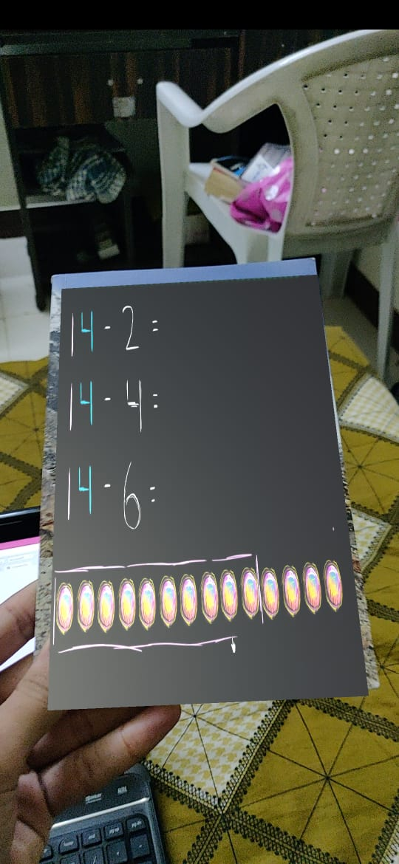 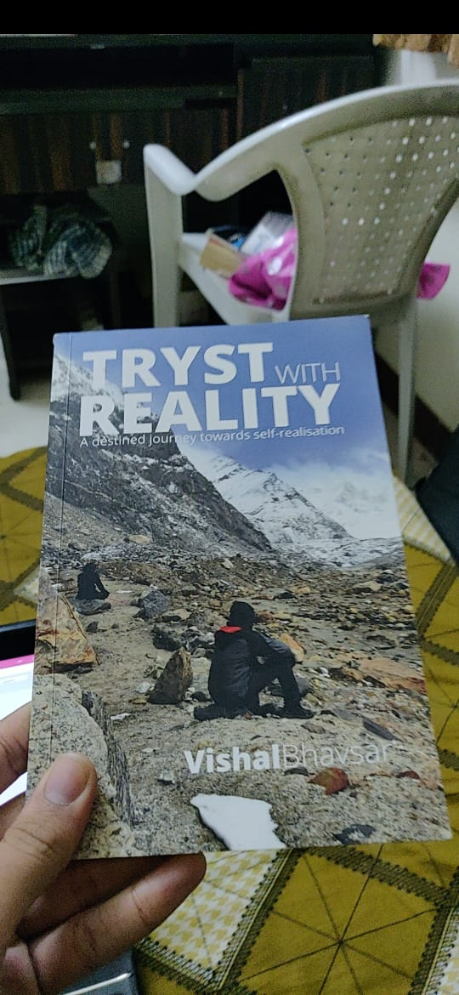

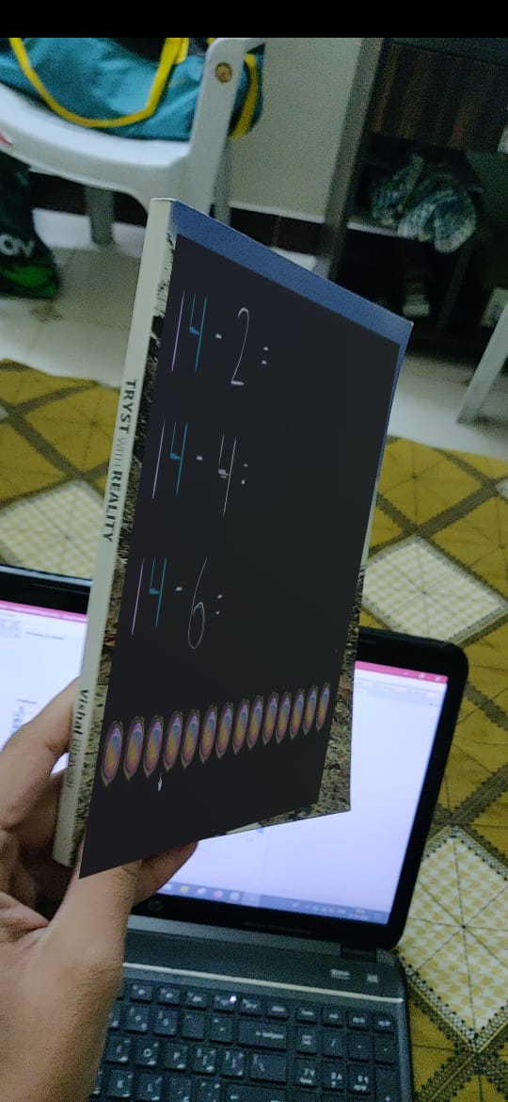

Behind the scene:

**Image Recognition**:

* + - Google AR Core Library determines/extract set of features from given image.
    - It can be in form of edges, colors and etc.
    - It is then saved. Latter whenever camera detects image, it is processed through arcore library and it determines whether is in predefined set or not.
    - If image is present in the dataset, then its coordinates are marked, it is done with the help of unity Engine.

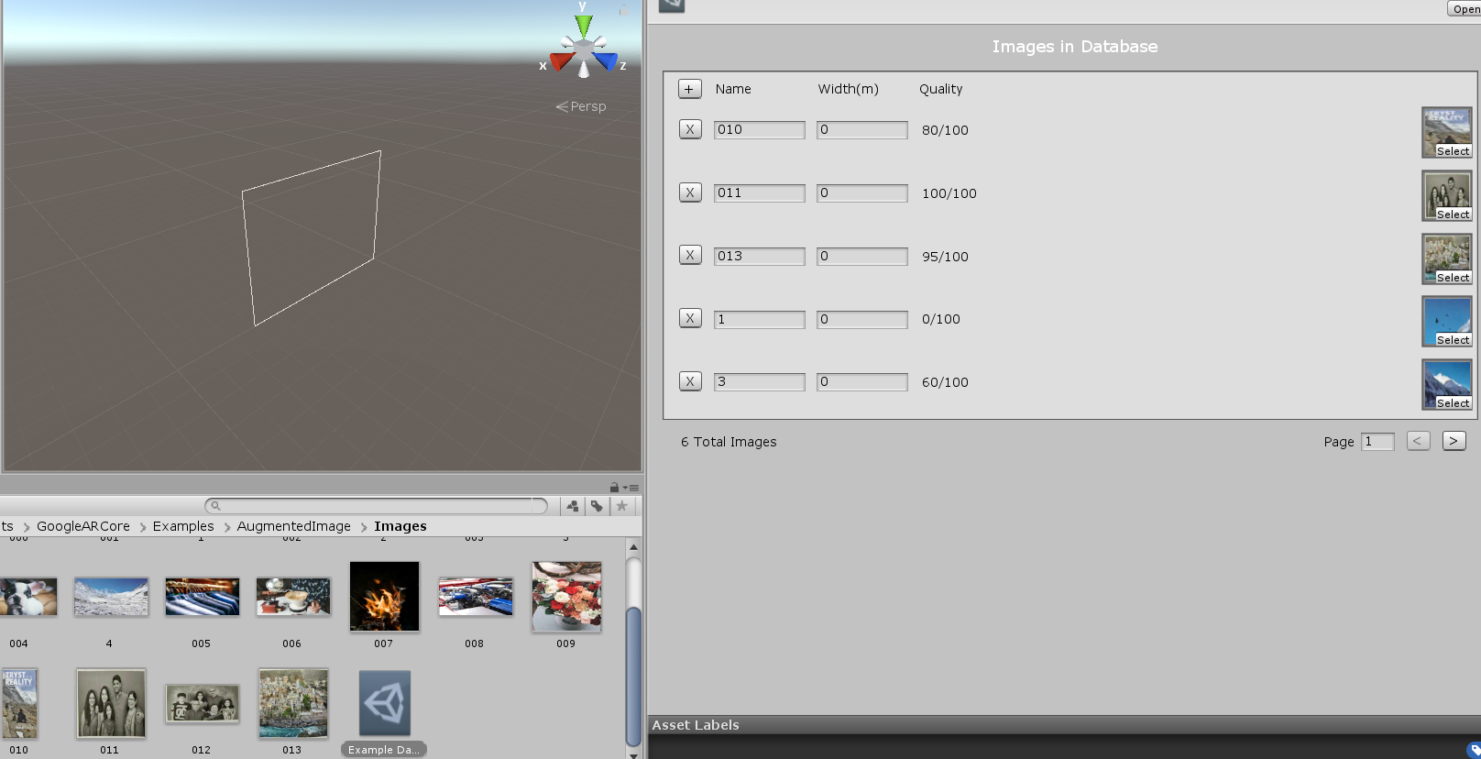

Example Dataset contains dataset of predefined images.

Quality is type of score for image. In other words, score for feature point out of 100.

Higher the score, better the recognition.

**Co-Ordinates**

Once coordinates are marked, we simply need to put/augment object onto it.

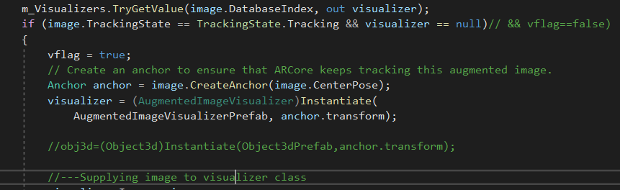

Creating anchor, so that we can sustain object onto it.

**Vector**

Representation of 3d Space.



**Transform Object**

Scaling, rotating and other orientation that needs to be performed to have better experience, objects are transformed according to image orientation.



Transformation of visualizer.

**Augment Object into Video/Image**



*Above Step/Process is repeated indefinitely.

Use Case 3:

Hunt It ~AR Game

Reference:

AR Core Docs

AR Core Tutorials